Assignment 1 - Due September 15th 9:00 AM Out of 30 Marks [ /30]

Instructions:
- Complete each question in Python.
- Use the formatted python document to write your code in. Save the file as firstname_lastname_assignment1.py
- Submit both your Python file and the completed testing charts for each question.
- You do not have to fill out every row of the table; you may add rows if needed.
- Be sure to carefully test your programs, record any errors, and describe how you fixed them.
- Make sure to use comments in your code.

Question 1: Say Hello /3

Write a program that asks the user for their name and prints: Hello, <name>!

Test Date | What you expect to happen | What actually happened | Screenshot | How you fixed it | What type of error did you have? Compile, run time or logic?
2025/09/23 | I expected the code to ask for the useres name then say hi, to the user | It just printed {name} instead of the actual name | 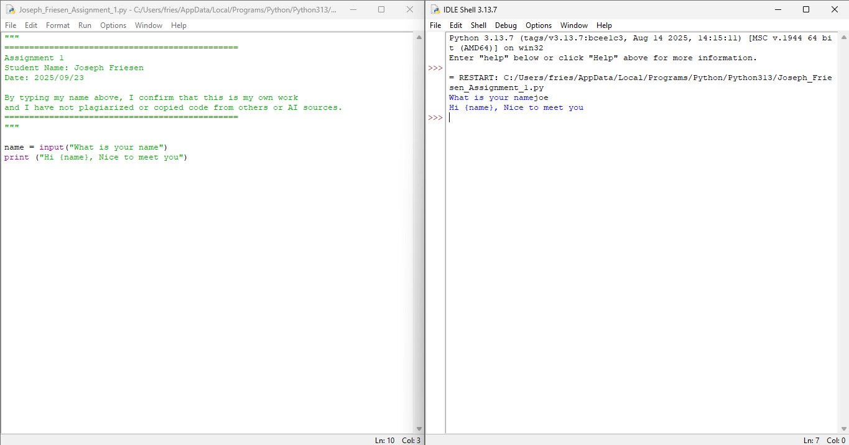 | I will try to look back the lessons and find why it printed it wrong.
2025/09/23 | I expected the code to ask for the useres name then say hi, to the user | It worked correctly | 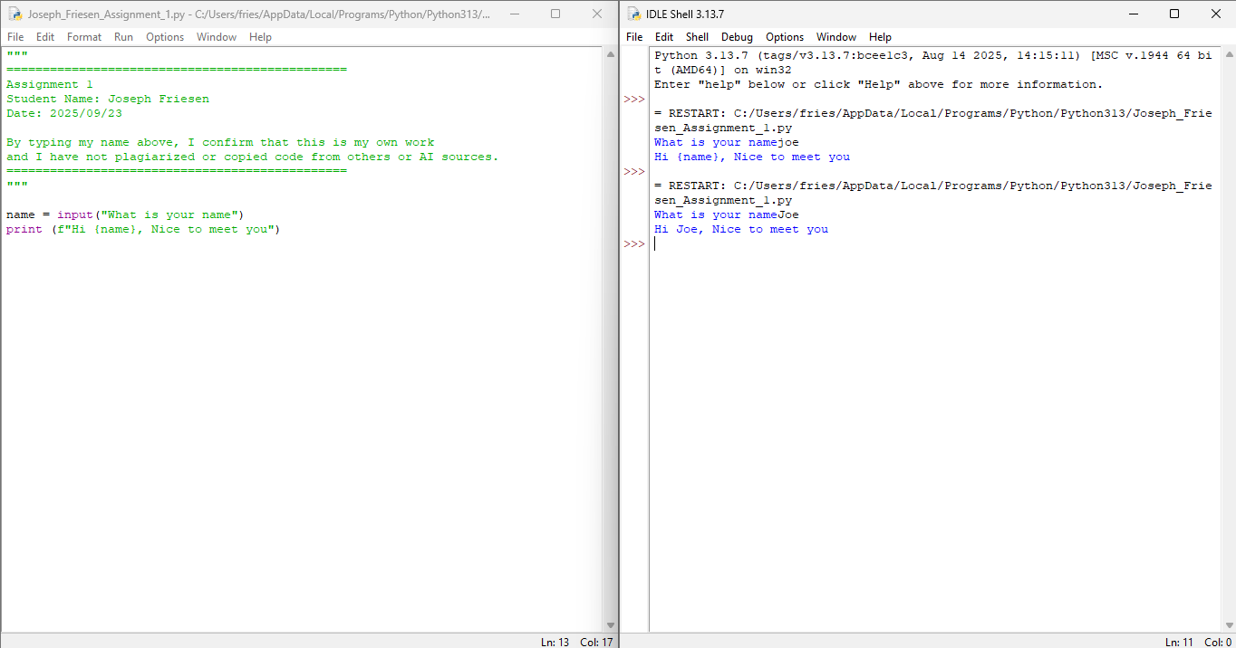 | I put the f in the code, because I forgot it

Question 2: Adding Numbers /3

- Ask the user to enter two numbers.
- Add them together and print the result.

Test Date | What you expect to happen | What actually happened | Screenshot | How you fixed it | What type of error did you have? Compile, run time or logic?
2025/09/23 | To ask for the 2 numbers and then add them | It had an error, suggesting that it was a missing comma | 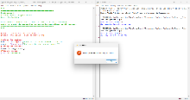 | I will try to find a solution, by looking back | syntax
2025/09/23 | To ask for the 2 numbers and then add them | It worked | 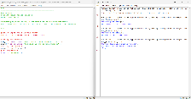 | I was missing a closing bracket on each line

Question 3: Average of Three Numbers /4

- Ask the user to enter three numbers.
- Calculate the average and print it.
- Remember average is the three numbers added together and divided by 3

Test Date | What you expect to happen | What actually happened | Screenshot | How you fixed it | What type of error did you have? Compile, run time or logic?
2025/09/23 | To give me the average | It had an error to add the numbers | 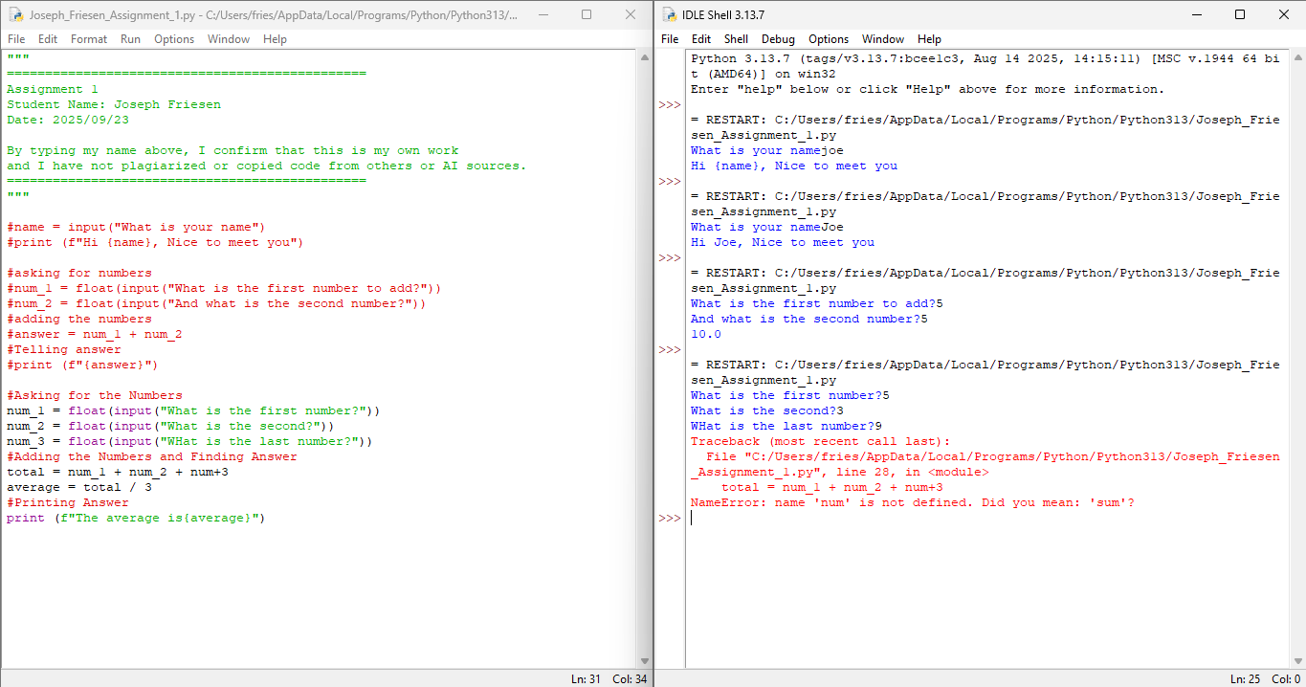 | I saw right away that I did a + by accident instead of the underscore
2025/09/23 | To give me the average | It worked perfectly | 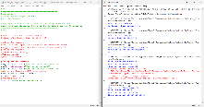 | I replaced the plus for an underscore

Question 4: Pizza Shop – Calculate Tax /5

- Imagine you are at a pizza shop.
- Ask the user to enter the total cost of their order (a number).
- Calculate 13% tax on that total.
- Print the total amount including tax.

Example (user enters 20):
Tax: 2.6
Total with tax: 22.6

Test Date | What you expect to happen | What actually happened | Screenshot | How you fixed it | What type of error did you have? Compile, run time or logic?
2025/09/23 | To give the tax and total price of the order | It worked | 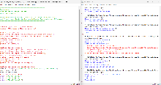

Question 5: Rectangle Area Calculator /5

- Ask the user to enter the length and width of a rectangle.
- Calculate the area of the rectangle.
- Print the result in a clear message.
- Remember area = length * width

Example (user enters 5 for length and 10 for width):
The area of the rectangle is 50

Test Date | What you expect to happen | What actually happened | Screenshot | How you fixed it | What type of error did you have? Compile, run time or logic?
2025/09/23 | I expected it to find the area with the given lengths | It worked | 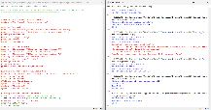

Question 6: Tip Calculator /5

- Ask the user to enter the total bill amount at a restaurant.
- Ask the user to enter a tip percentage they want to leave (e.g., 15 for 15%).
- Calculate the tip amount and the total bill including tip.
- Print both values clearly.

Test Date | What you expect to happen | What actually happened | Screenshot | How you fixed it | What type of error did you have? Compile, run time or logic?
2025/09/23 | To give the tip amount, the price, and the total (tip and price together) | It had an error | 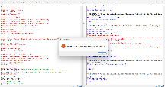 | I will fix the incorrect parentheses | syntax
2025/09/23 | To give the tip amount, the price, and the total (tip and price together) | It worked | 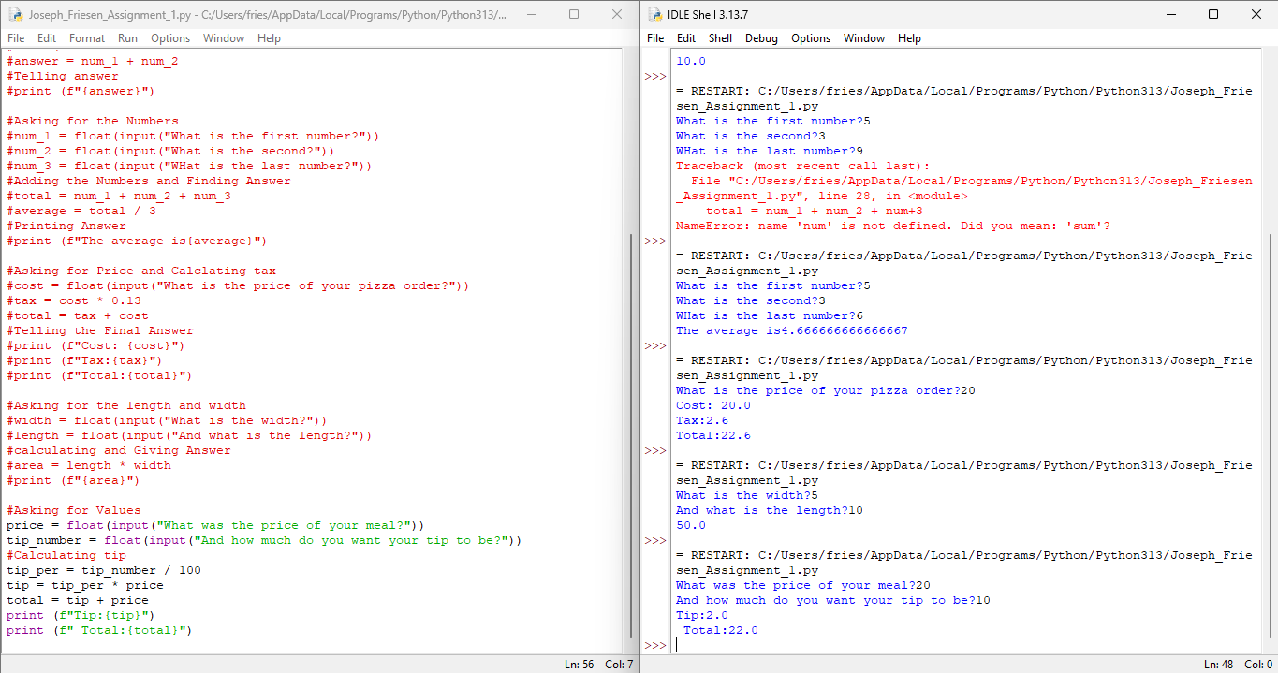 | I fixed the parentheses from a “{“ to a “(“

